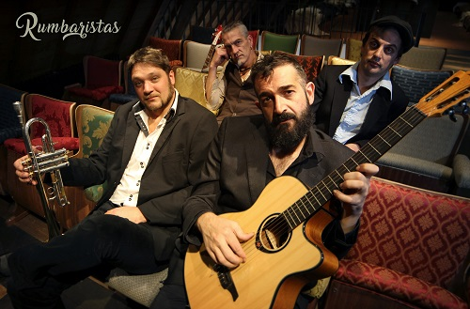

RUMBARISTAS
‘CANHAVERAL CALIENTE’ !!

‘Rumbaristas’ is the rather hot name of a cool collective consisting of musicians with Spanish, French and Belgian roots. They gathered around the Catalan rumba-player Willy Fuego and the French-Italian-Polish composer Thomas Morzewski to form a new project based on their mutual musical interests, and are now collecting an ever growing group of followers in the alternative world-music scene.
Their repertoire? A well balanced lively and colourful mix of latin-american flavours with the passion of the Balkan music, combined with Catalan rumba and Sicilian tarantelle. And where they can spicing it up a little with a touch of ska, reggae or cumbia.

Those who have been following the Barcelonian mestizo scene a little, and by extension that of the whole of Spain, will most certainly already have heard of Willy Fuego, the moniker of Jose Luis Ferrer Sanchez. He’s a singer, guitar- and bassplayer and has allready earned his fame in playing in bands as Jaleo Real and La Kinky Beat as well as being the side-kick of Amparo Sanchez. Willy Fuego is an interesting musical personality, at some points a little shy, and is finding his inspiration in the nostalgicness which gives rise to heartaches. An often recurring theme in his work.

In september 2016 Willy Fuego embarked on a new trip to Belgium with his small spanish guitar as his sole piece of luggage. He arrives in Tournai, where he used to work to promote his first solo-album ‘Acontracorriente’ and where he starts working on new material with some fellow musicians, most of them people he has met over the last few years when being in these parts. It’s there that is born the idea of linking up Willy Fuego with some other talented and latin inspired musicians from the French and Belgian world music scene.

Thomas Morzewski (aka Dom Tomasino), composer and trumpetplayer with l’ Orchestre International du Vetex, is a prominent international influence. With his french, sicilian and polish roots he has over the past few years created a heavily versatile musical repertoire, always characterized by vivid and open melodies, blending centra land southern european influences.

It’s obvious that this rather unusual combination of the ‘latino’ Willy Fuego and the ‘balkan touch’ of Thomas Morzewski creates a fascinating and unique musical universe. Add the rhythm section formed by Roel Poriau (drums/percussions) and Thomas De Smet (bass/upright bass) – both of Think of One fame (the belgian band that between 1999 and 2006 made a unique mix of ‘world music’ and got awarded for that with a BBC World Music Award) – and you get a fresh and sincere sound.

Light and delicat, joyfull and at times even explosive, the music of Rumbaristas mixes different styles such as rumba, tarantella, son, cumbia, reggae or ska in original compositions which immediately draw the listeners attention, creating the immediate seire to dance and sing along with the mesmerizing choruses. Rumbaristas is an authentic and fascinating band, an imaginairy encounter between Saban Bajramovic and Gato Perez, making people dance from Lille to Gerona, from Catania to Antwerp…

Line-up :

Willy Fuego : Spanish guitar and lead vocals
Thomas Morzewski : accordion + trumpet + keyboards + lead vocals
Roel Poriau : drums + percussions + backing vocals
Thomas De Smet : bass + backing vocals

